**CHAPTER 1:**

### INTRODUCTION TO DATABASE MANAGEMENT SYSTEM

Formally, a 'Database' refers to a set of related data and the way it is organised. Access to this data is usually provided by 'Database' management system”(DBMS) consisting of an integrated set of computer software that allows the users to interact with one or more databases and provides access to all of the data contained in the database(although restrictions may exist that limit access to particular data). The DBMS provides various functions that allow entry, storage and retrieval of large quantities of information and provides ways to manage how that information is organised.

Because of the close relationship between them, the term 'database' is often used casually to refer to both the database and the DBMS used to manipulate it.

Outside the world of professional information technology, the term Database is often used to refer to any collection of related data (such as spreadsheet or a card index) as however size and usage requirements typically necessitates use of database management system.

Existing DBMSs provide various functions that allow management of a database and its data which can be classified into four main functional groups:

* Data Definition: - Creation, modification and removal of definitions that define organization of data.
* Update: - Insertion, modification and deletion of actual data.
* Retrieval: - Providing information in a form directly usable or for further processing by other applications. The retrieved data may be made available in a form basically combining existing data from the database.
* Administration: - Registering and monitoring uses, enforcing data security, monitoring performance, maintaining data integrity, dealing with concurrency control and recovering information that has been corrected by some event such as unexpected system failure.

Both the database and its DBMS confirm to the principles of particular database model. “Database system” refers collectively to the database model, database management system and database.

Physically, database servers are dedicated computers that hold the actual databases and run only the DBMS and related software. Database servers are usually multiprocessor computers, with generous memory and RAID disk arrays used for stable storage. RAID is used for recovery of data if any of the disks fail. Hardware database accelerators, connected to one or more servers via a high-speed channel, are also used in large volume transaction processing environments.

DBMSs are found at the heart of most database applications. DBMSs maybe built around a customer multitasking kernel with built in networking support, built modern DBMSs typically rely on standard operating system to provide these functions.

Since DBMSs comprise a significant market, computer and storage vendors often take into account DBMS requirements in their own development plans.

Databases and DBMSs can be categorised according to database model(s) that they support (such as relational or XML, the type(s) of computer they run on “from a server cluster to a mobile phone “ , the query language(s) used to access the database such as SQL or XQuery) , and their internal engineering , which effects performance, scalability , resilience

1.1 HISTORY OF DBMS:

The sizes, capabilities and performance of databases and their respective DBMSs have grown in orders of magnitude. These performances increases where enabled by the technology progress in the areas of processor computer memory, computer storage and computer networks. The development of database technology can be divided sinto three eras based on data model or structure: Navigational, SQL / relational and post relational.

The two main early navigational data models were the hierarchical model and the Codasyl model (network model).The next generation of post-relational databases in the late 2000s became known as No SQL databases , introducing fast key-value stores and document-oriented databases a completing “ next generation “ known as New SQL databases attempted new implementations that retained the relational / SQL model while aiming to match the high performance of No SQL compared to commercially available relational DBMSs .

1.2 DEFINITION:

A database management system is a computer-software application that interacts with end-users, other applications, and the database itself to capture and analyse data. A general purpose DBMS allows the definition, creation, querying, update, and administration of databases .Well-known DBMS’s;- include MySQL, PostgreSQL, Enterprise DB , MongoDB, Maria DB, Microsoft SQL Server, Oracle, Sybase, SAP HANA, Mem SQL , SQLite and IBM DB2.

A database is not generally portable across different DBMSs, but different DBMSs can interoperate by using standards such as SQL and ODBC or JDBC to allow a single application to work with more than one DBMS. Computer scientists may classify database management systems according to the database models that they support; the most popular database systems since the 1980s have all supported the relational model generally associated with the SQL language.

1.3 USES OF DATABASE:

Applications of Database are many, however some of them are as explained below:

* Databases for Businesses: The business world depends on databases 24 hours a day, seven days a week. Inventory, order processing, payroll, accounting, shipping and transportation routing are often tracked within a main database that keeps the company functioning.
* Databases for Education: From elementary schools to colleges, educational institutions use databases to keep track of students, grades, transfers, transcripts and other student data. There are even specialized database packages geared toward schools and college.
* Databases for Non-Profits: Like businesses and educational institutions, non-profit organizations use systems to track information. Many charities and other non-profit groups use a database to store details of donations, volunteers, hours served in the community, clients helped and other information related to the organization.
* Databases for Household and Family Management: The database also has a role in household and family management. Many people use databases to keep track of family birthdays, bills and expenses in the home; addresses of friends and relatives and movie/DVD collections.
* Everyday Uses for Databases: Each time you make a purchase and the sales clerk asks for your address or ZIP code, your information is kept and stored on a customer database. These collections of data are used to send mailings of special offers, discounts and other deals.

1.4 ADVANTAGES:

* An organized and comprehensiveness of recording the result of the firms activities.
* A receiver of data to be used in meeting the information requirement of the MIS users.
* Reduced data redundancy.
* Reduced updating errors and increased consistency.
* Greater data integrity and independence from applications programs.
* Improved data access to users through use of host and query languages.
* Improved data security.
* Reduced data entry, storage, and retrieval costs.
* Facilitated development of new applications program.
* Standard can be enforced: Standardized stored data format is particularly desirable as an old data to interchange or migration (change) between the systems.
* Conflicting requirement can be handled.

1.5 INTRODUCTION TO PROJECT MANAGEMENT SYSTEM:

In general, a [project management software](http://en.wikipedia.org/wiki/Project_management_software" \t "_blank) is the one which helps plan, organize, and handle resource pools and develop resource estimates. Depending on the scope of the application, these resources may be estimating and valuation, [planning and tracking](https://www.codewithc.com/planning-tracking-system-asp-net-project/" \t "_blank" \o "Planning and Tracking System ASP.NET Project), resource allocation, cost control and budget management, decision-making, quality management and communication.

Project management system or project tracking system is a web-based application developed using PHP. This is an academic project proposed with a website where [students](https://www.codewithc.com/online-student-management-system-asp-net-project/" \t "_blank) can search for projects from previous years and their current project details.

**Chapter 2:**

**SYSTEM ANALYSIS**

System analysis is the detailed study of the various operations performed by the system and their relationship within and outside the system. Analysis is the process of breaking something into its parts so that the whole maybe understood .System analysis is concerned with becoming aware of the problem, identifying the relevant and most decisional variables, analyzing and synthesizing the various factors and determining an optimal or at least a satisfactory solution. During this a problem is identified, alternate system solutions are studied and recommendations are made about committing the resources used to design the system.

**2.1 EXISTING SYSTEM:**

The existing system Register inquiry information required in the system is entered and maintained totally manually. Manually maintain the customer details personal info. Many registers have to be maintained.

Means, it is very complex which give the information about Channels customer.

This new web application admin site is also available. So, when if we want to change any type of data then upload second time this site.

Limitations of existing system:

1. It is time consuming.

2. Right information is not retrieved at right time.

3. Any updates to the data by team members or the Project coordinator or guide cannot see immediately by the rest of the team.

4. All work is done manually.

**2.2 PROPOSED SYSTEM:**

In context of the proposed project, let’s look at the need/demand of this type of application. Most of the [universities](https://www.codewithc.com/university-admission-management-system-java-project/" \t "_blank) and colleges today use their official website for keeping track of projects uploaded by senior students. Such projects can be helpful to juniors, and being visible on the web, these projects can be downloaded by students from any location.

In present context, only few of such university websites provide security that allows only college students to access the website and get relevant materials from there. So, in this application, a website has been designed where users can register with username and password. They can search, upload, and download projects from the website.

**2.3 OBJECTIVES OF PROPOSED SYSTEM:**

A project objective describes the desired results of a project, which often includes a tangible item. An objective is specific and measurable, and must meet time, budget, and quality constraints.

1. State your **objectives** in quantifiable terms.
2. State your **objectives** as outcomes, not process.
3. **Objectives** should specify the result of an activity.
4. **Objectives** should identify the target audience or community that you plan to serve.
5. **Objectives** need to be realistic and something you can accomplish within the grant period.

**Chapter 3:**

**SYSTEM REQUIREMENT SPECIFICATION**

In this section the various requirements that are essential for this project are specified. These requirements have to be fulfilled for successful execution of the project. The purpose, scope along with hardware and software requirements is given below:

**3.1 HARDWARE REQUIREMENTS:**

Processor: Intel(R) Core™ i7-8550U CPU

Hard Disk capacity: 64-bit Operating System, x64-based processor

RAM: 8 GB

Clock Speed: 1.80 GHz

**3.2 SOFTWARE REQUIREMENTS:**

Operating System: Windows 10

Front End: CSS, HTML, JavaScript

Back End: PHP

Database: MySQL (XAMPP)

**Chapter 4:**

**SYSTEM DESIGN**

**4.1 DATABASE DIAGRAM:**

Database design is the organization of data according to a database model. The designer determines what data must be stored and how the data elements interrelate. With this information, they can begin to fit the data to the database model. Database management system manages the data accordingly.

**The design process consists of the following steps:**

1. Determine the **purpose** of your database. ...
2. Find and organize the information required. ...
3. Divide the information into tables. ...
4. Turn information items into columns. ...
5. Specify primary keys. ...
6. Set up the table relationships. ...
7. Refine your design. ...
8. Apply the normalization rules.

**4.1.1 E R DIAGRAM:**

An ER diagram shows the relationship among entity sets. ... In terms of DBMS, an entity is a table or attribute of a table in database, so by showing relationship among tables and their attributes, ER diagram shows the complete logical structure of a database.

**4.2 Implementation:**

The implementation phase involves putting the project plan into action. It's here that the projectmanager will coordinate and direct project resources to meet the objectives of the project plan. As the project unfolds, it's the projectmanager's job to direct and manage each activity, every step of the way.

**4.2.1 Modules Description:**

**4.2.1.1 ADMIN Module:**

The Admin manages all the management like adding students, adding faculty members, searching for student and faculty member and so on. The Admin has an important role in managing the activities for the student/faculty.

CODE:

<! DOCTYPE html PUBLIC "-//W3C//DTD XHTML 1.0 Transitional//EN" "http://www.w3.org/TR/xhtml1/DTD/xhtml1-transitional.dtd">

<html xmlns="http://www.w3.org/1999/xhtml">

<head>

<meta http-equiv="Content-Type" content="text/html; charset=utf-8" />

<style>

body

{

background-image:url();

background-repeat: no-repeat;

background-attachment: fixed;

background-size: 100% 100%;

}

</style>

<title>Project Management System</title>

</head>

<div>

<body>

<table width="100%" border="0"cellspacing="00" cellpadding="00">

<tr bgcolor="#459aa3">

<th width="74" scope="col">&nbsp;</th>

<th width="164" scope="col"><img src="images/logo1.png" alt="LOGO"></th>

<th width="646" scope="col"><font size="8" color="White">Project Management System</font></th>

<th width="140" scope="col"><font color="White" size="5">

<?php

print $role;

?></font></th>

<th width="63" scope="col">&nbsp;</th>

</tr>

</table>

<table width="100%" border="0" cellspacing="0" cellpadding="0">

<tr bgcolor="#cb64e8">

<th width="5%" scope="col"><h4>&nbsp;</h4></th>

<th width="12%" scope="col"><a href="ADMIN/student.php">Add Student</a></th>

<th width="11%" scope="col"><a href="ADMIN/faculty.php">Add Faculty</a></th>

<th width="11%" scope="col"><a href="ADMIN/stsearch.php">Search Student</a></th>

<th width="11%" scope="col"><a href="ADMIN/fa\_search.php">Search Faculty </a></th>

<th width="11%" scope="col"><a href="ADMIN/allocate.php">Allocate</a></th>

<th width="11%" scope="col"><a href="ADMIN/skill.php">Skill Matrix</a></th>

<th width="11%" scope="col"><a href="ADMIN/report.php">Reports</a></th>

<th width="11%" scope="col"><a href="logout.php">Logout</a></th>

<th width="6%" scope="col">&nbsp;</th>

</tr>

<tr>

<td colspan="10"><img src="home.png" height="50%" width="100%"></img></td>

</tr>

</table>

<?php

**4.2.1.2 FACULTY MODULE**:

The Faculty members can update their skills and check their mails and so on.

CODE:

<!DOCTYPE html PUBLIC "-//W3C//DTD XHTML 1.0 Transitional//EN" "http://www.w3.org/TR/xhtml1/DTD/xhtml1-transitional.dtd">

<html xmlns="http://www.w3.org/1999/xhtml">

<head>

<meta http-equiv="Content-Type" content="text/html; charset=utf-8" />

<style>

body

{

background-image:url();

background-repeat: no-repeat;

background-attachment: fixed;

background-size: 100% 100%;

}

a link{

text-decoration: none;

}

</style>

<title>Project Management System</title>

</head>

<div>

<body>

<table width="100%" border="0"cellspacing="00" cellpadding="00">

<tr bgcolor="#459aa3">

<th width="74" scope="col">&nbsp;</th>

<th width="164" scope="col"><img src="images/logo1.png" alt="LOGO"></th>

<th width="646" scope="col"><font size="8" color="White">Project Management System</font></th>

<th width="140" scope="col"><font color="White" size="5">

<?php

print $role;

echo "<br/>";

print $user;

?>

</font></th>

<th width="63" scope="col">&nbsp;</th>

</tr>

</table>

<table width="100%" border="0" cellspacing="00" cellpadding="00">

<tr bgcolor="#cb64e8">

<th width="7%" scope="col"><h4>&nbsp;</h4></th>

<th width="15%" scope="col"><a href="FACULTY/skill.php">Skill Matrix</a></th>

<th width="14%" scope="col"><a href="FACULTY/view.php">View</a></th>

<th width="15%" scope="col"><a href="FACULTY/mail.php">Mail</a></th>

<th width="13%" scope="col"><a href="FACULTY/meeting.php">Meeting</a></th>

<th width="15%" scope="col"><a href="logout.php">Logout</a></th>

<th width="6%" scope="col">&nbsp;</th>

</tr>

<tr>

<td colspan="10"><img src="home.png" height="50%" width="100%"></img></td>

</tr>

</table>

<?php

**4.2.1.3 STUDENT MODULE:**

### The students can upload their project, view skills of faculty members, and can mail to faculty members. While uploading the project they can separately send their project Proposal or Specification and can receive the feedback for it.

<!DOCTYPE html PUBLIC "-//W3C//DTD XHTML 1.0 Transitional//EN" "http://www.w3.org/TR/xhtml1/DTD/xhtml1-transitional.dtd">

<html xmlns="http://www.w3.org/1999/xhtml">

<head>

<meta http-equiv="Content-Type" content="text/html; charset=utf-8" />

<style>

body

{

background-image:url();

background-repeat: no-repeat;

background-attachment: fixed;

background-size: 100% 100%;

}

a link{

text-decoration: none;

}

</style>

<title>Project Management System</title>

</head>

<div>

<body>

<table width="100%" border="0"cellspacing="00" cellpadding="00">

<tr bgcolor="#459aa3">

<th width="74" scope="col">&nbsp;</th>

<th width="164" scope="col"><img src="images/logo1.png" alt="LOGO"></th>

<th width="646" scope="col"><font size="8" color="White">Project Management System</font></th>

<th width="140" scope="col"><font color="White" size="5">

<?php

print $role;

echo "<br/>";

print $user;

?></font></th>

<th width="63" scope="col">&nbsp;</th>

</tr>

</table>

<table width="100%" border="0" cellspacing="0" cellpadding="0">

<tr bgcolor="#cb64e8">

<th width="7%" scope="col"><h4>&nbsp;</h4></th>

<th width="13%" scope="col"><a href="STUDENT/project.php">Project</a></th>

<th width="12%" scope="col">&nbsp;</th>

<th width="13%" scope="col"><a href="STUDENT/skill.php">View Skill Matrix</a></th>

<th width="11%" scope="col">&nbsp;</th>

<th width="13%" scope="col"><a href="STUDENT/mail.php">Mail</a></th>

<th width="12%" scope="col">&nbsp;</th>

<th width="13%" scope="col"><a href="logout.php">Logout</a></th>

<th width="6%" scope="col">&nbsp;</th>

</tr>

<tr>

<td colspan="10"><img src="home.png" height="50%" width="100%"></img></td>

</tr>

</table>

<?php

**Chapter 5:**

**TESTING**

5.1 System Testing:

The goal of the system testing process was to determine all faults in our project. The program was subjected to a set of test inputs and many explanations were made and based on these explanations it will be decided whether the program behaves as expected or not. Our Project went through two levels of testing.

1. Unit Testing
2. Integration Testing

**UNIT TESTING**

Unit testing is commenced when a unit has been created and effectively reviewed. In order to test a single module we need to provide a complete environment i.e. besides the section we would require

* The procedures belonging to other units that the unit under test calls.
* Non local data structures that module accesses.
* A procedure to call the functions of the unit test with appropriate parameters.

1. **Test for the ADMIN module**

* **Testing admin login form-**This form is used for login of admin, faculty or student of the system. In this form we enter the id, password and select for Login As (Admin/Faculty/Student). If all are correct then their respective dashboard page will open otherwise if any of the data is wrong it will get redirect back to the login page and again ask for the details.
* **Report Generation:** Admin can only generate report from the main database

**INTEGRATION TESTING**

In the Integration testing we test various combination of the project module by providing the input.

The primary objective is to test the module interfaces in order to confirm that no errors are occurring when one module invokes the other module.

**Chapter 6:**

**SCREEN SHOTS**

**6.1 LOGIN FORM:**

The login form allows Admin/Faculty/Student to login into the application

**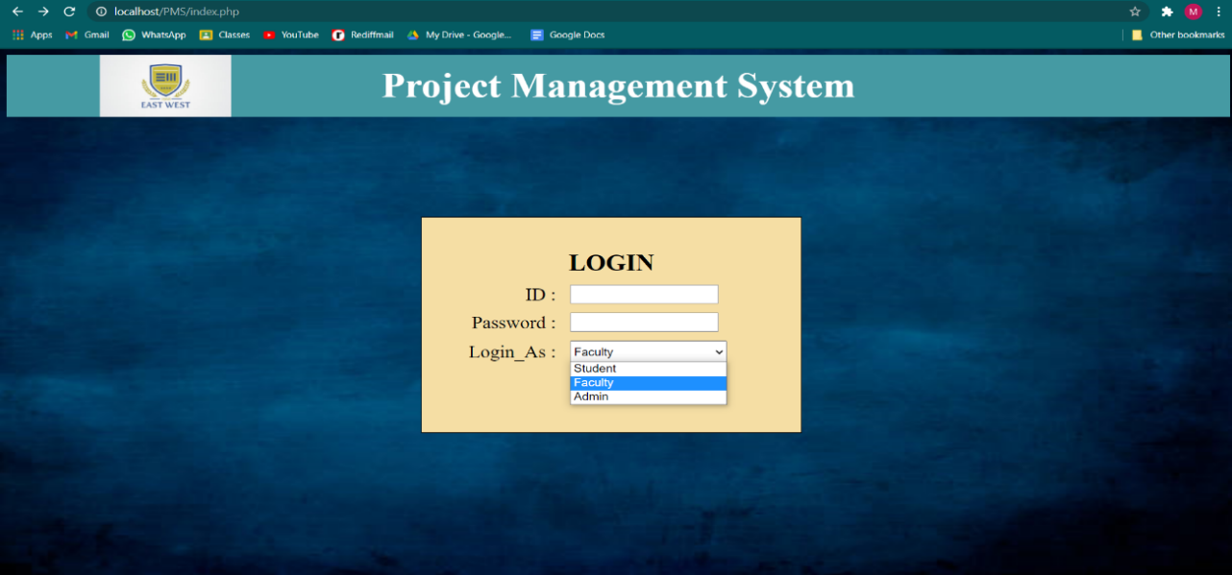**

Fig.6.1: Login Page

**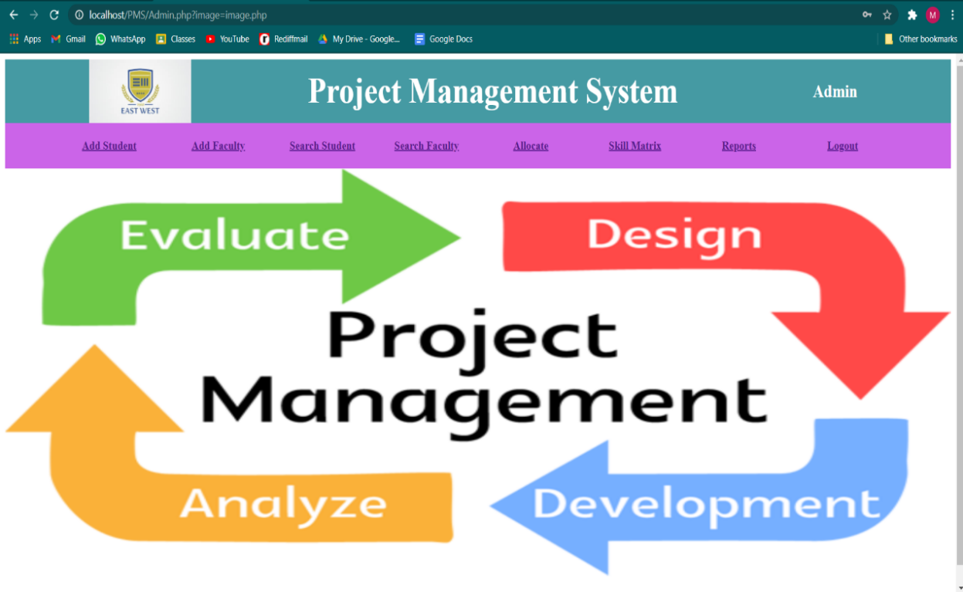**

Fig. 6.2: Admin Dashboard

**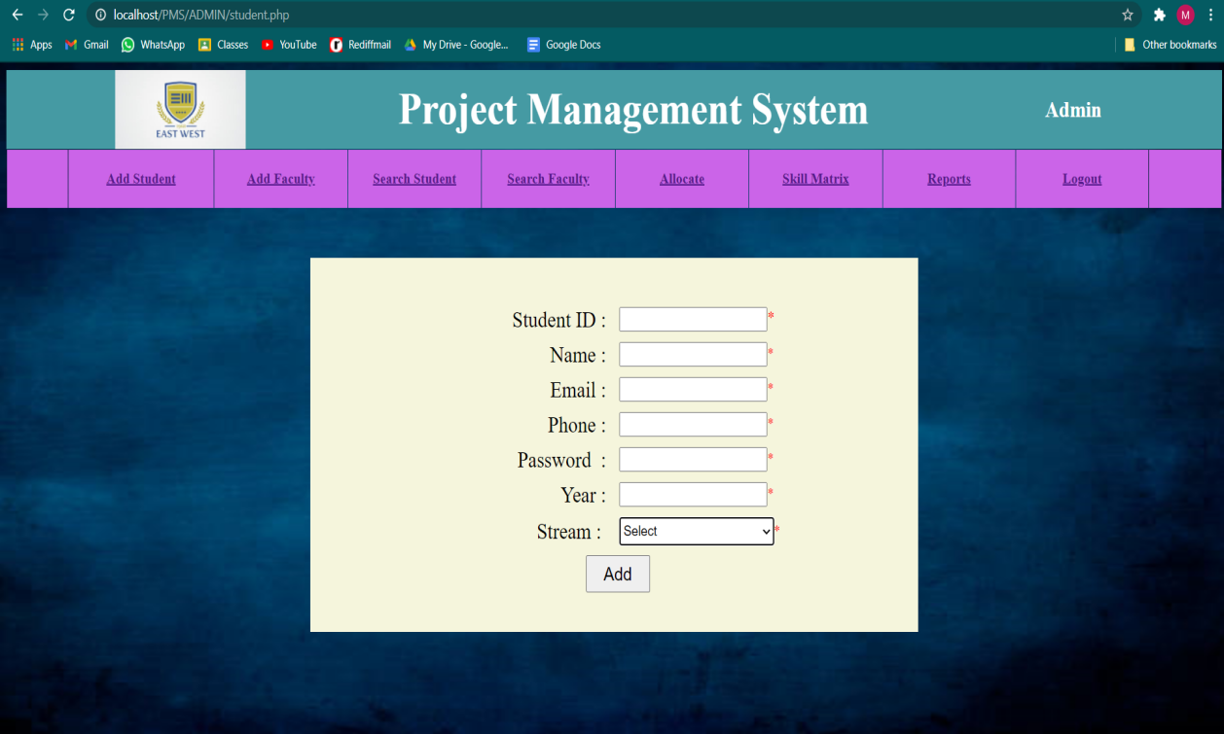**

FIG 6.3: ADD STUDENT

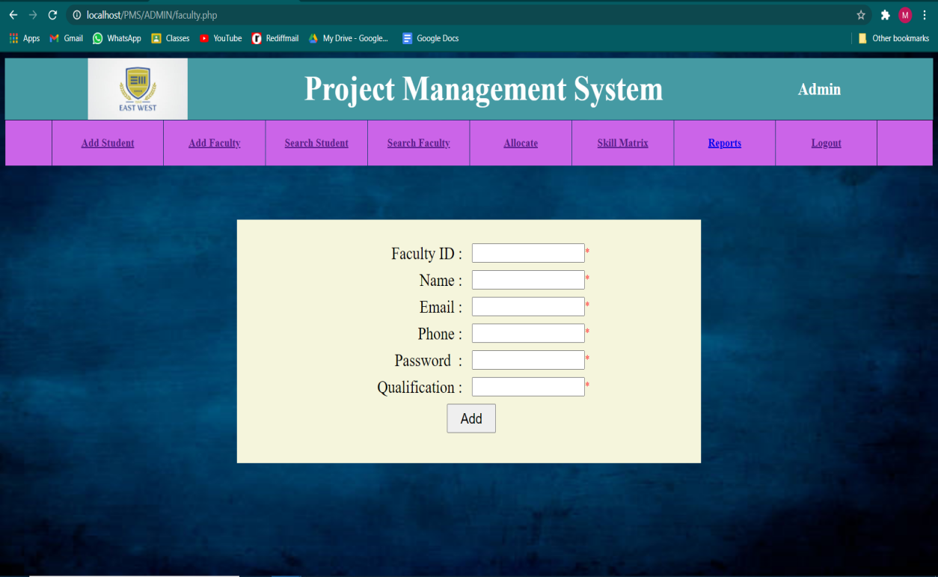

FIG 6.4: ADD FACULTY

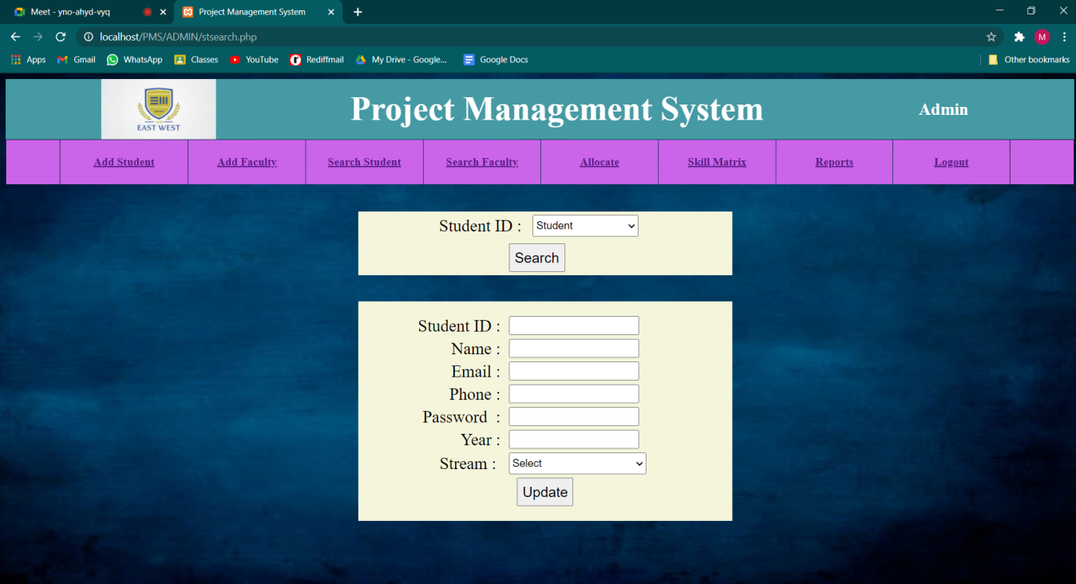

FIG 6.5: SEARCH STUDENT

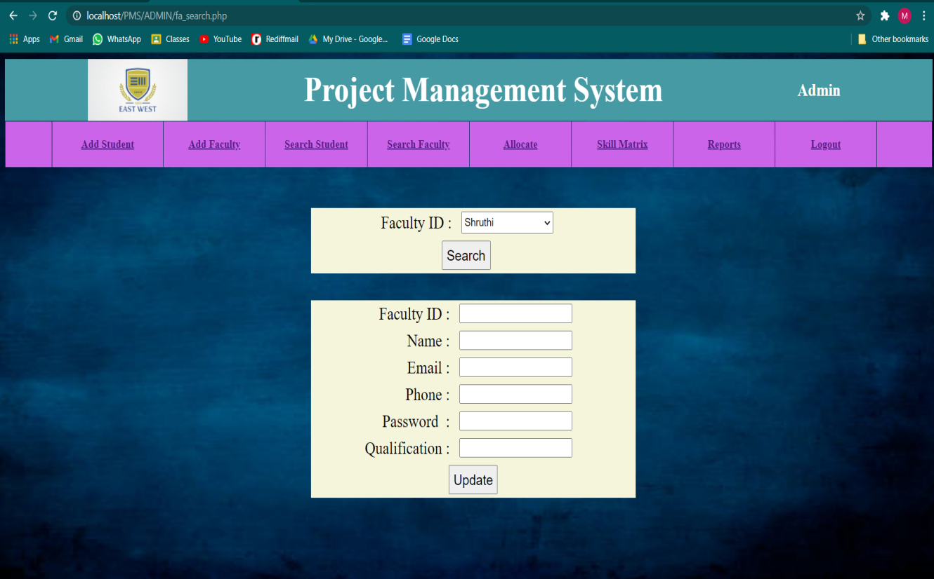

FIG 6.6: SEARCH FACULTY

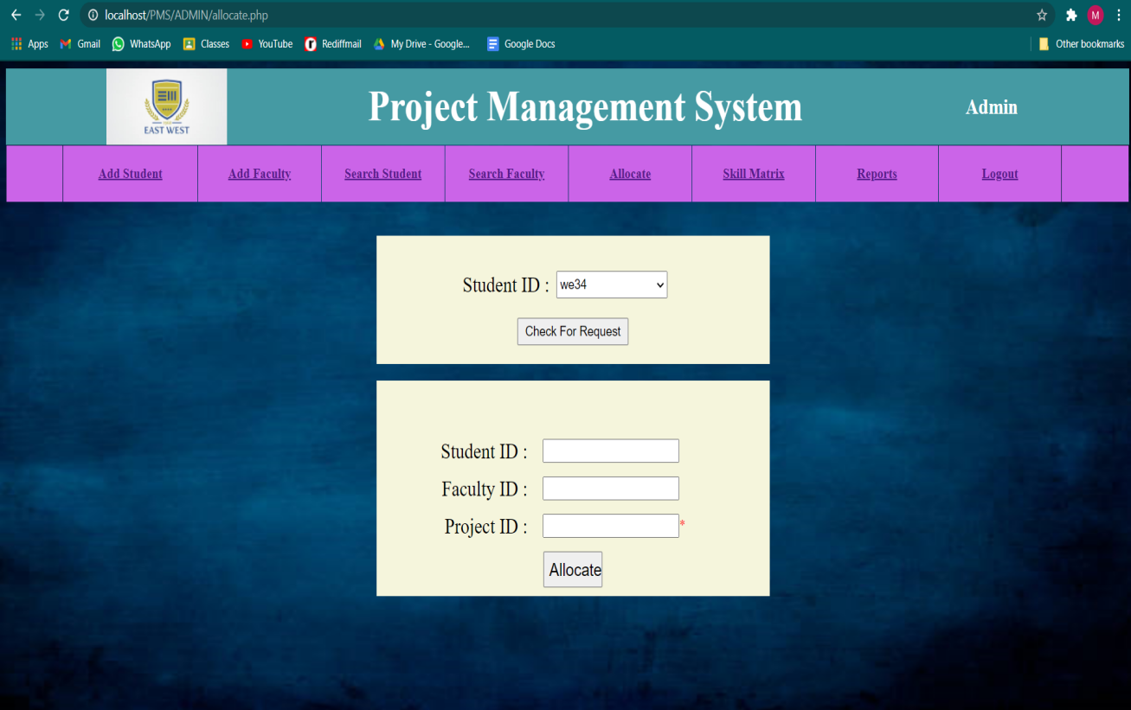

FIG 6.7: ALLOCATE

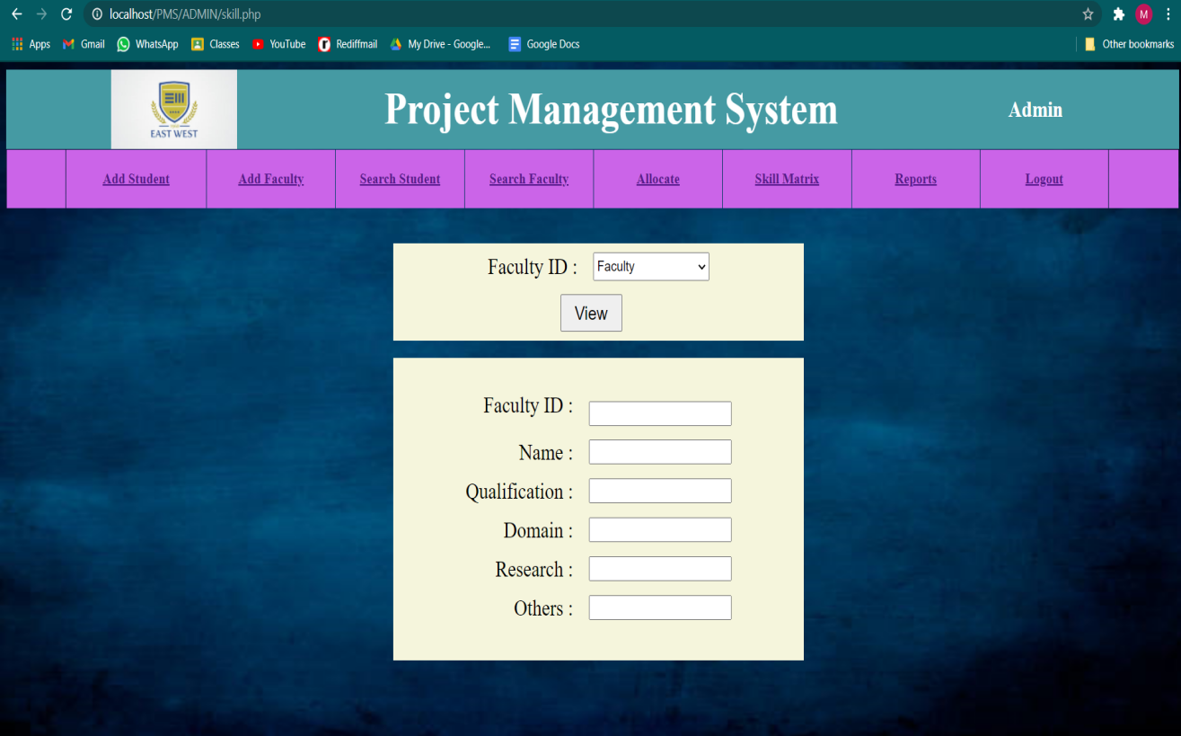

FIG 6.8: SKILL MATRIX

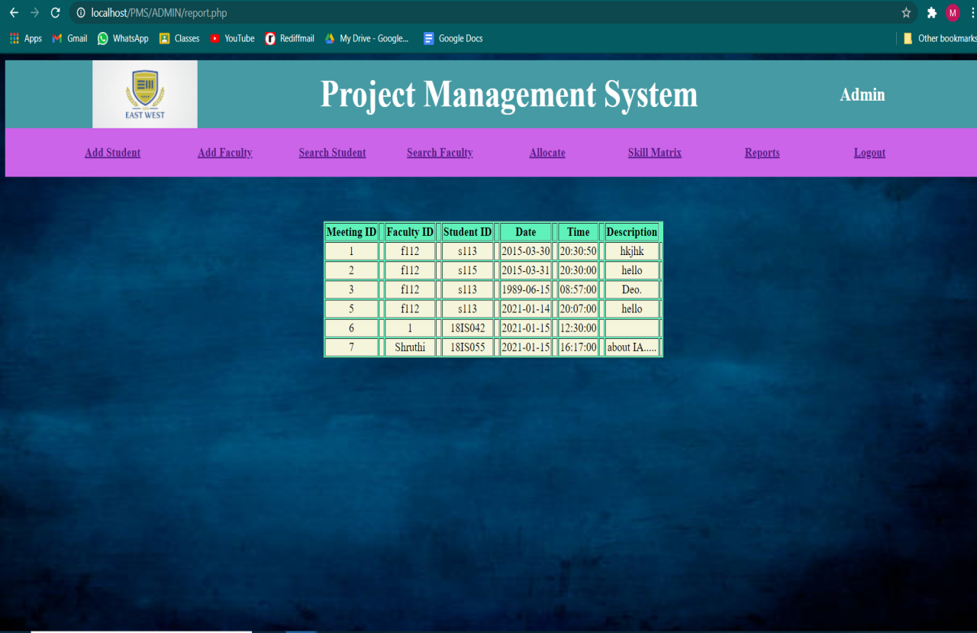

FIG 6.9: REPORTS

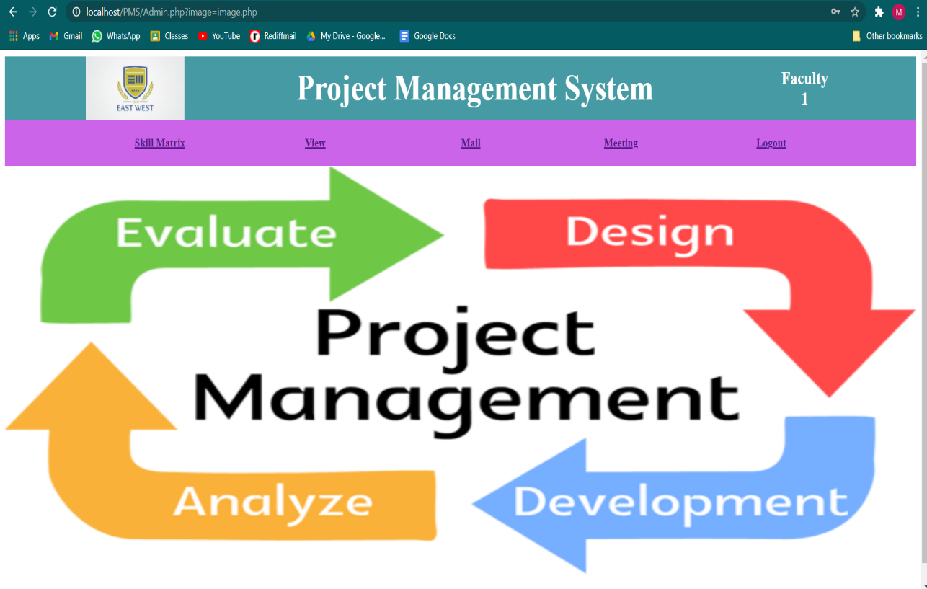

6.10: FACULTY-DASHBOARD

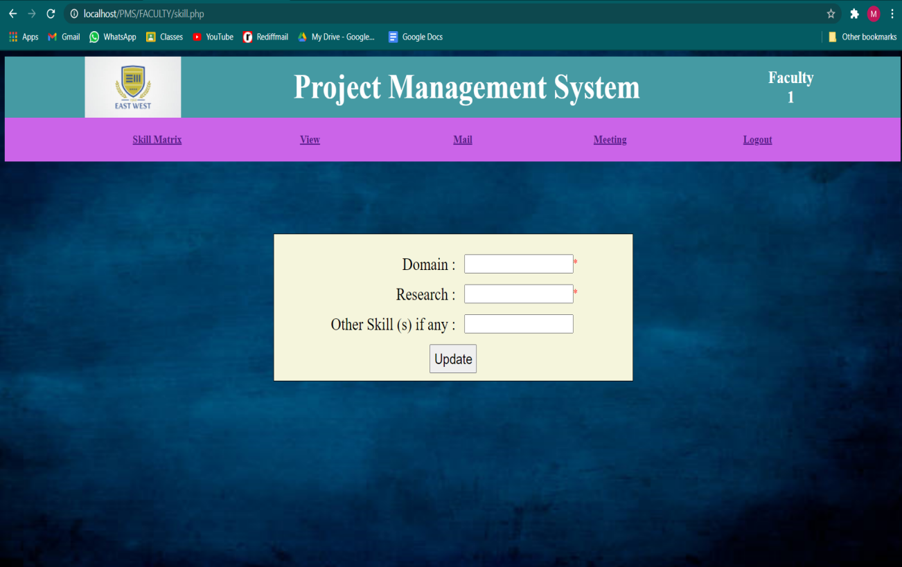

FIG 6.11: FACULTY-SKILL MATRIX

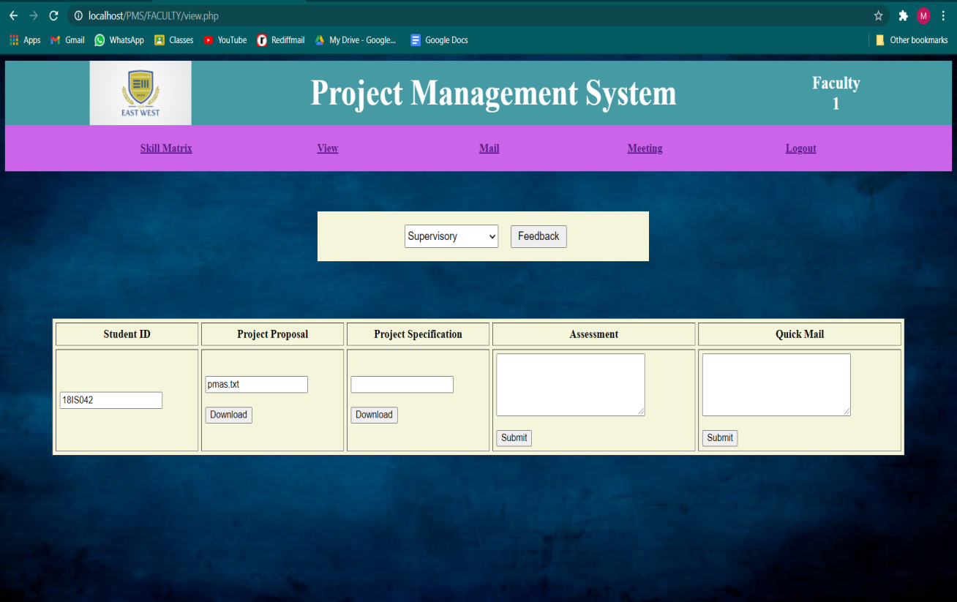

FIG 6.12: FACULTY-VIEW

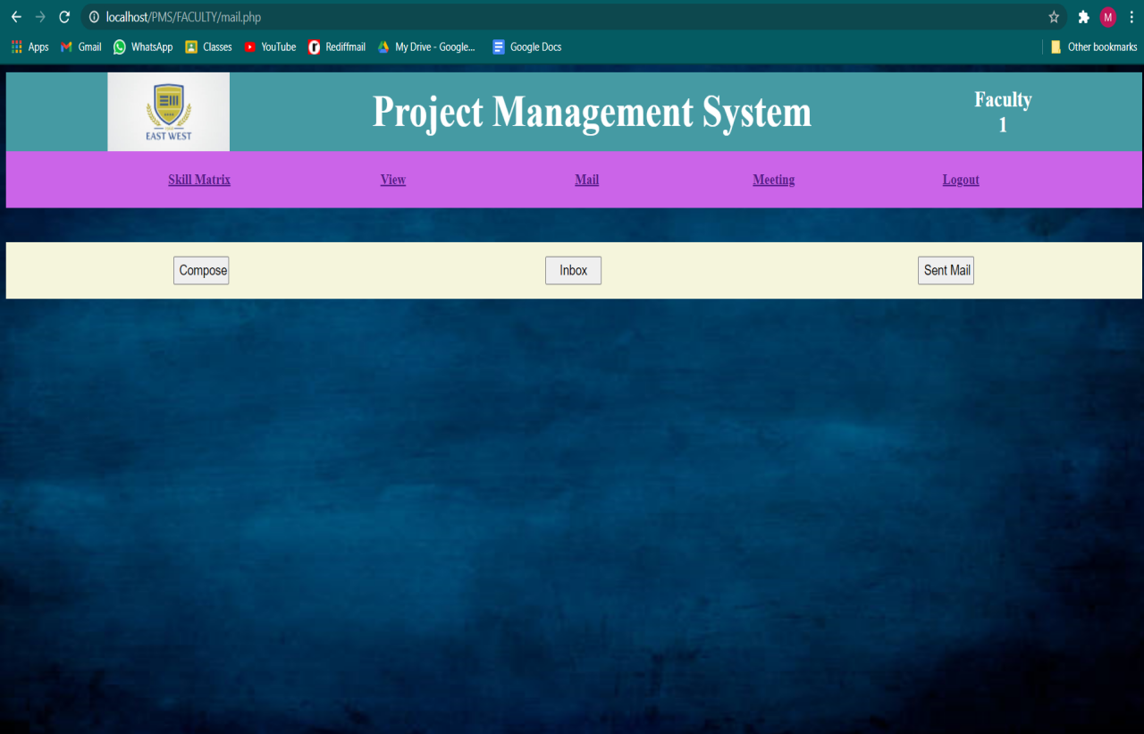

FIG 6.13: FACULTY-MAIL

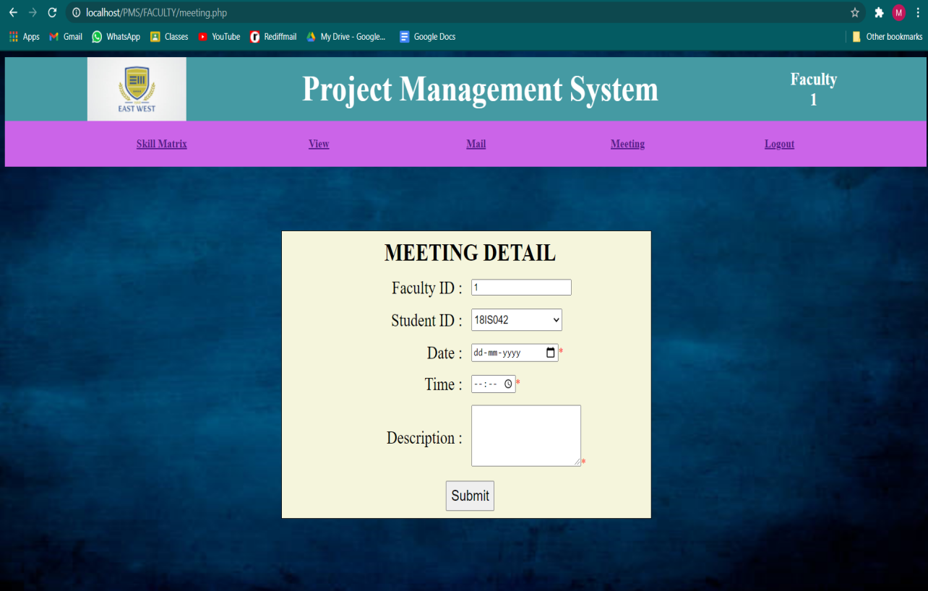

FIG 6.14: FACULTY-MEETING

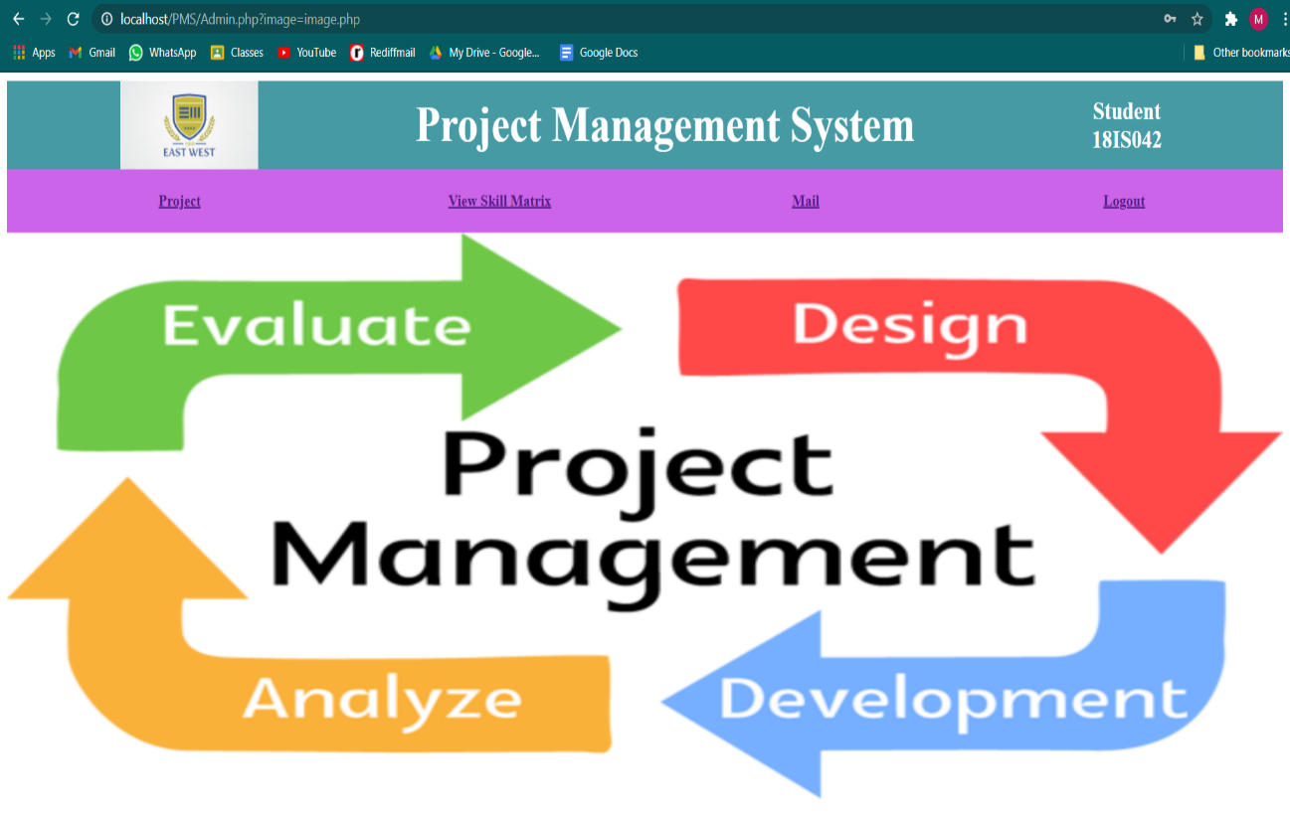

FIG 6.15: STUDENT DASHBOARD

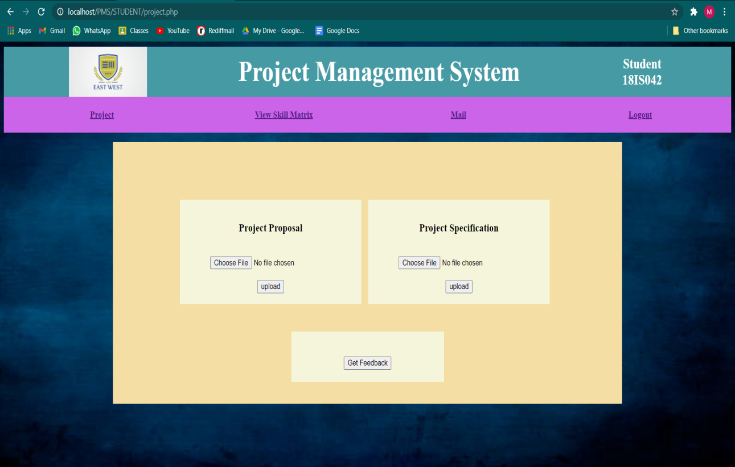

FIG 6.16: STUDENT-PROJECT

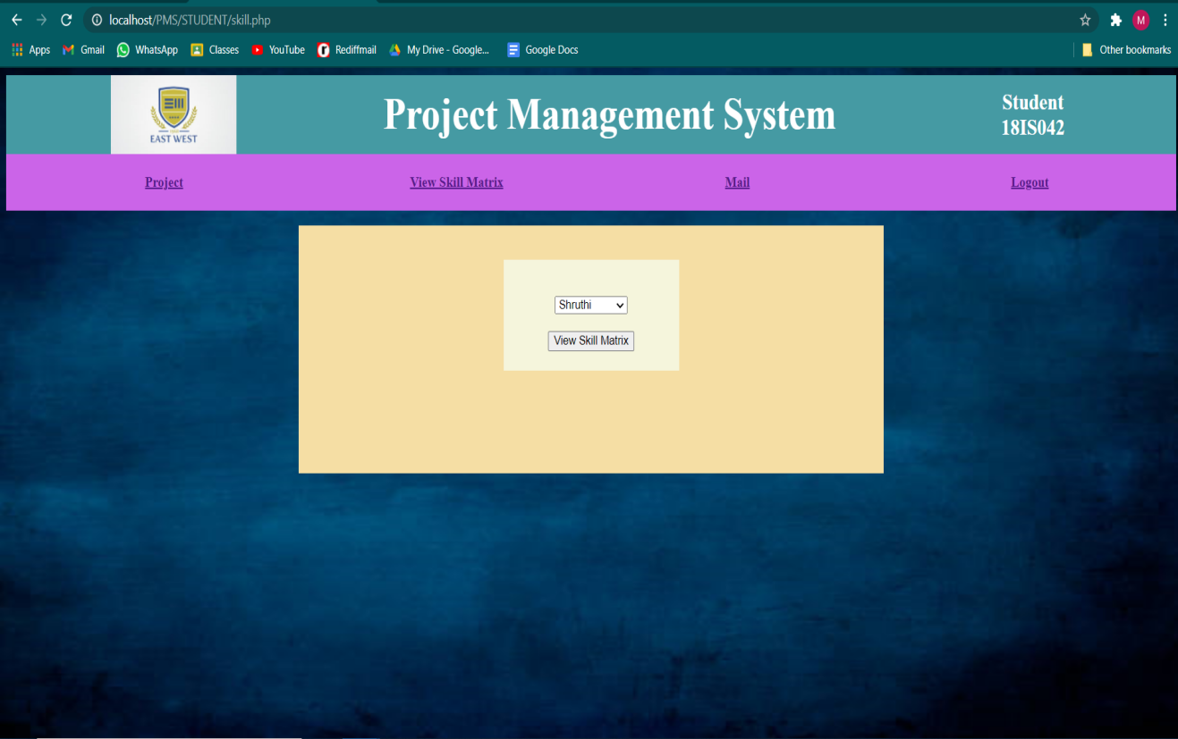

FIG 6.17: STUDENT-VIEW SKILL MATRIX

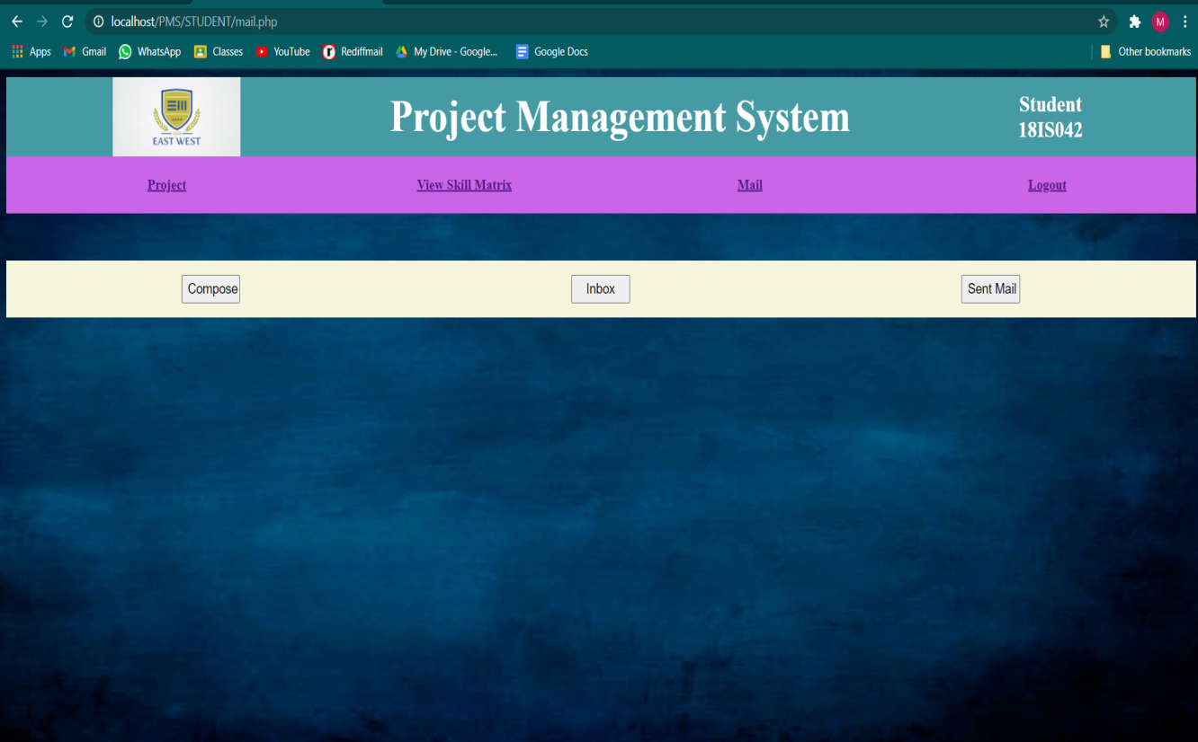

FIG 6.18: STUDENT-MAIL

**CONCLUSION**

In context of the project, let’s look at the need/demand of this type of application. Most of the colleges today use their official website for keeping track of projects uploaded by the students. Such project can be useful for the colleges.

In present context, only few of such college websites provide security that allows only college students to access the website. So, in this application, a website has been designed where users can register with username and password. They can search, upload, and download projects from the website.

**REFERENCES**

**Book Referred:**

1. Fundamentals of Database System - Ramez Elmasri, Shamkant Navathe 2017 (7th Edition).
2. Database Management System - Ramakrishnan and Gehrke 2014 (3rd Edition).
3. MySQL The Complete Reference - Vikram Vaswani 2004

**Websites:**

* Google
* W3 Schools
* Git hub
* Geeksforgeeks
* <http://localhost/phpmyadmin/>
* Php tutorial